The City of Wolverhampton Council
Corporate Parenting Strategy 2021 - 2024
Forward
Councillor Momenabadi Cabinet Member for Children and Young People
Mark Taylor Deputy CEO/Emma Bennett – Executive Director for Families
CiCC and CLIC endorsement Statement
Introduction
This strategy sets out Wolverhampton City Council’s vision and commitment and explains how we, as the Council, will be an effective and trustworthy corporate parent. Our children and young people in and leaving care are some of the most vulnerable in society. It is crucial we as Corporate Parents work collaboratively with a range of partners to ensure they are supported for them to be safe, happy and thrive.
This Strategy has been co-produced with our Children in Care Council, Care Leavers Independent Collective and The Corporate Parenting Partnership Board and has been endorsed by the Corporate Parenting Board. This is a three-year Corporate Parenting Strategy outlines our commitments, challenges, and the key steps we shall take to ensure that our children have the best possible outcomes in life.
Our key partners which include public services, private sector, the voluntary sector and the wider community all have their part to play. By working together, we can support our children and those leaving care to take advantage of the range of opportunities our city can offer to help them to reach their full potential.
Every good parent should ensure that:
- Children are safe and in a secure environment
- Children are protected and are supported against the dangers and risks of life.
- Children are ambitious reach their full potential.
- Children are celebrated and other share in their achievements.
A child who is cared for by the City of Wolverhampton Council has the right to expect everything from a corporate parent that would be expected from a good parent.
Definitions
Corporate Parenting is the term used in law to describe our collective responsibility to care for, love and champion our children in care and our care leavers and ensure they have every opportunity to reach their full potential as they grow up.
The concept of Corporate Parenting was introduced by the Government in 1998 as part of a drive to improve the lives of children who are care for by the local authority. The Corporate Parenting responsibility was reiterated and reinforced in 2007 with the release of the White Paper Care Matters-Time for Change and the underpinning legislation, Children and Young People Act 2008. The Children and Social Work Act 2017 which now requires all local authorities to evidence how they meet the seven Corporate Parenting Principles as they are statutory in relation to children and young people in and leaving care,
The Corporate Parenting Principles for children in care and care leavers, are:
- To act in the best interests, and promote the physical and mental health and well-being, of those children and young people
- To encourage those children and young people to express their views, wishes and feelings
- To take into account of the views, wishes and feelings of those children and young people
- To help those children and young people gain access to, and make the best use of, services provided by the local authority and its relevant partners
- To promote high aspirations, and seek to secure the best outcomes, for those children and young people
- For those children and young people to be safe, and for stability in their home lives, relationships and education or work
- To prepare those children and young people for adulthood and independent living.
Our Vision
Our Vison for this strategy is to ensure we are working with children and young people in and leaving care in a collaborative and co-productive way. The City of Wolverhampton Council recognises and celebrates its role as Corporate Parents and acknowledges that children and young people in care and care leavers have the right and responsibility to shape how services work for them. The strategy will take a City-wide approach to drive forward, support and strengthen the areas of good practice and work with key partners in the statutory, voluntary and private sectors. The voice of children and young people will be at the heart of service design, delivery and evaluation, including democratic decision-making processes. As corporate parents, relationships and connection will be at the core of everything we do. We will work collaboratively with children and young people to enable us to get things right for them. We will always have high aspirations and high expectations, develop respectful and empowering relationships with our children and young people, we will see their strengths, celebrate their achievements and create many lasting happy memories. The strategy will look at the areas of work that are needed to support young people in and leaving care over the next three years. This will then develop into the Corporate Parenting Strategy Action Plan, which will be overseen by the Corporate Parenting Board.
Legislations that relates to this strategy
• Children Act 1989
• United Nations Convention on the Rights of the Child 1989
• The Children (Leaving Care) Act 2000
• Children and Social Work Act 2017
What our young people say needs to happen?
The Priorities of the Care Leavers Independent Collective and Children in Care Council need to be at the forefront of the progression of this Strategy. These are their priorities.
Care Leavers Independent Collective  Priorities  - Rent reduction for working care leavers  - Apprenticeships/Uni offer with more ring-fenced posts outside of children’s services and support for EET co-ordinator  - Heath access/ Mental Health- glasses, dental and equipping young people with skills to cope with adversity and to engage with available support  - Digital Poverty  - Transport  - Professional being accountable to young people | Children in Care Council  Priorities  1. Celebrating the achievements of young people  2. Workers understanding the feelings of young people and listening to their views  3. More consistency and contact with social workers.  4. To make sure of early intervention and to keep young people safe at all times  5. Young people should be given more choices

What our young people and our partners say need to happen?
Strengths:
- We are dedicated and passionate
- The voice of our young people is strong and valued by all including senior leaders
- There is good emotional and wellbeing support
- Co-production on service and policy development
- We have high aspirations and everyone wanting the best
- There is strong partnership working with equal offers of support, information, forward thinking and joined up working
- Integrated approach, celebration events, awareness of achievements, stakeholder engagement
- Young people’s voice respected, support with mental health, training flat, house project, ASDAN award and peer support
- Support and options for accommodation for young people leaving care
- Support for Education, Employment and Training

Challenges:
- Communication support for young people and keeping young people up to date with support on offer
- Digital inclusion
- Transport
- Equality of opportunity and support for those young people living out of city,
- Sustainability, stability and consistency at home for children and young people
- Preparing for adulthood support to foster carer

Then each of the principles there are areas of focus based on the feedback from children and young people in and leaving care and the relevant stakeholders.
- To act in the best interests, and promote the physical and mental health and well-being, of those children and young people
- Share good practice across the partnership
- Demonstrate clearly the ways we are listening to young people
- Communicate effectively with our children and young people what support is there.
- To encourage those children and young people to express their views, wishes and feelings
- Provide different tools for engagement
- Endorse and share with young people that there are constant feedback opportunities
- To take into account of the views, wishes and feelings of those children and young people
- Celebrate the views of young people
- Share good practice
- To help those children and young people gain access to, and make the best use of, services provided by the local authority and its relevant partners
- Access to affordable transport
- Inclusive and clear use of language
- Ensure services and provisions are accessible and financially viable for young people
- To promote high aspirations, and seek to secure the best outcomes, for those children and young people
- Sharing the success of young people across the partnership
- Commitment from all stakeholders to showcase and secure opportunities and consistent support
- For those children and young people to be safe, and for stability in their home lives, relationships and education or work
- Varied offer from education providers
- ambitious expectations for young people
- Support in for care leavers in employment to be practical and flexible
- To prepare those children and young people for adulthood and independent living.
- To start independent skills earlier with Children in Care,
- All young people to complete the ASDAN award

As a result as a Council we will
- Know our children, their needs, talents and aspirations and promote their interests
- Hold high aspirations for their future and expect the best for and from them
- Take an interest in their successes and problems and show our pride in their achievements, and celebrate them
- Listen to their views and ensure they influence practice, service developments and policy.
- Ensure they are consulted about their own lives and plans
- Recognise, support and respect their identity in all aspects
- Promote and support high academic achievement.
- Support their health and emotional well-being and resilience
- Support transition to adult life and promote their economic prospects & prepare them to become responsible citizens.
Our Commitment
The City of Wolverhampton Council has a unique responsibility to children who are in care or leaving care as their ‘corporate parents’. In simple terms, a corporate parent is intended to carry out many of the roles a parent would. The Council may not be able to provide everything a loving parent can, but they will provide the children and young people they are responsible for with the best possible support and care.
This strategy has been co-produced with the Children in Care Council and Care Leavers Independent Collective, each principle has been evaluated analysing the strengths, challenges and what needs to happen. This feedback will form the basis of the Corporate Parenting Action plan and will be reviewed annually.

Who are our Children in care?

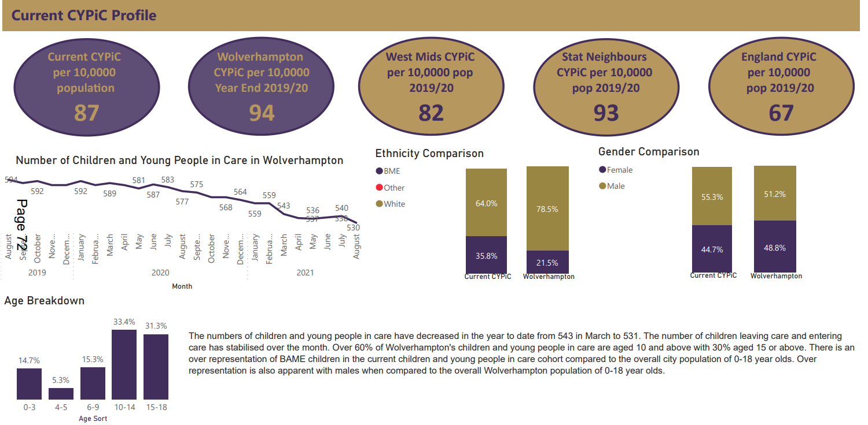

Who are our Care Leavers?

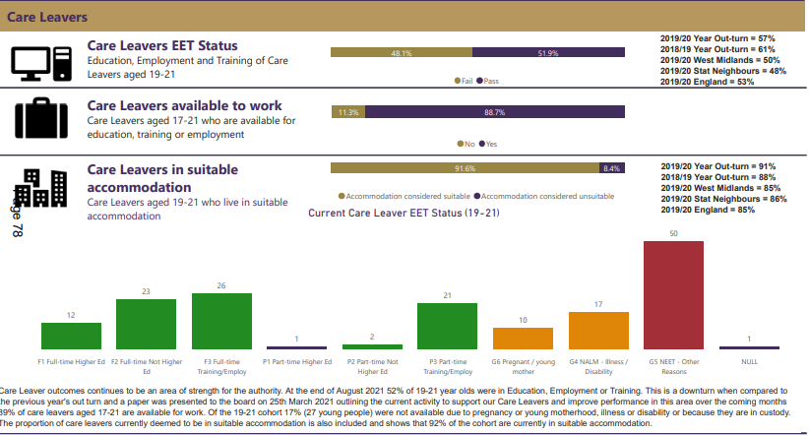

Governance

The Corporate Parenting Board made up of elected members and Corporate Parenting Partnership Board made of partners will be influenced and guided by the Children in Care Council and Care Leavers Independent Collective as experts by experience and will be active partners in co-producing developments that effect Children in Care and Care Leavers.
The Governance of this strategy is committed to promote a strong corporate parenting ethos and consider how services can be delivered differently to meet the needs of the care population as effectively as possible. To be successful the City of Wolverhampton Council it is vital that the council recognises, celebrates and promotes the importance of its partners in the statutory, private and third sector. The City of Wolverhampton Council alone cannot meet the needs of Children in Care and Care Leavers and needs to work effectively with partners to demonstrate the statutory Corporate Parenting Principles.
Whilst this strategy is the City of Wolverhampton Council document it is hoped that it will be adopted by our partners and the resultant Action Plan is held across all the sectors.
Children in Care Council
The Children in Care Council is made of young people aged 11-18 who are in care of the City Council, some living with foster carers, residential homes, friends and family carers and some living independently. These young people are nominated to become members by their social workers, Independent Reviewing Officers (IRO), foster carers or other professionals who feel that young people would benefit from the skills acquired as part of the council.
This group meets fortnightly. The young people completed induction training; interview training and some will complete the Total Respect Training. In addition to the group meeting they meet twice a year with the Corporate Parenting Board. The Children in Care Council work plan includes all of the reports sent to this board. This process is to ensure the experiences and opinions of the young people are imbedded into service delivery and development. This group attends national forums through the National Children’s Board which advises on national policy.
Care Leavers Independent Collective
The Care Leaver Independent Collective is made up of young people who are supported by the council leaving care team known as the Reach Team, these young people are 18 -25 and are either living independently, living with a host or staying put with foster carers. They are recruited to the forum through advertisements on Facebook, through their Young Person’s Advisors (YPA) or social worker.
The group meets fortnightly and has its meeting combined with a peer support element as these young people can be very isolated. The formal part of the meeting is for an hour and half where they look at policy developments and service provision and give feedback to officers. This group also takes part in the National Care Leaver Covenant and National Benchmarking Forum which feeds into national policy development for Care Leavers.
Corporate Parenting Partnership Board
Corporate Parenting Partnership Board is made up of colleagues from the Council, Police, Fire Service, Health Services, the Voluntary Sector and other relevant organisations. These colleagues are at an appropriate senior level within their organisation to be able to influence policy and strategy within their organisation to assist with the raising of opportunities and aspirations of our care population in line with the seven principles. The actions and recommendations agreed by this group will be shared with the Corporate Parenting Board, the Children in Care Council and the Care Leavers Forum.
The Corporate Parenting Board
The Corporate Parenting Board is made up of cabinet member for children and young people and 10 elected members. In addition, a care experienced young person and a foster carer are advisors and sit on the board. The board meets six times per year to consider and provide clear strategic and political direction in relation to corporate parenting. This includes satisfying themselves that
- All Councillors and the City of Wolverhampton Council Service Groups are all fulfilling their roles and responsibilities as corporate parents proactively and make a demonstrable commitment to prioritising the needs of looked after children and young people.
- The City has high ambitions and aspirations for all looked after children and care leavers.
- Undertake regular monitoring of the outcomes associated with the seven principles.
- Set objectives for monitoring the work of and evaluating the progress of the Senior Officers Group.

